UNIVERSITY OF SKILLS TRAINING AND ENTREPRENEURIAL DEVELOPMENT

FACULTY OF APPLIED SCIENCES AND MATHEMATICS EDUCATION
DEPARTMENT OF INFORMATION TECHNOLOGY EDUCATION

DESIGN AND DEVELOPMENT OF A SMART INFORMATION DISSEMINATION SYSTEM FOR ENHANCED STUDENT COMMUNICATION IN HIGHER EDUCATION

BY
BADU ADWOA NTIRIWAA - 5221040008
APPIAH JUSTICE BARFO - 5221040041
ASARE EDMUND BEDIAKO - 5221040297
THEOPHILUS KING ASARE - 5221040017
KYEI GYAMFI SOLOMON - 5221040042

1.0 INTRODUCTION
Effective communication is essential to the operation of higher education institutions. Students, lecturers and administrators depend on timely notices about admissions, registration, class schedules, examinations, fees, academic deadlines and emergency situations. This proposal presents the design and development of a smart information dissemination system that will provide a central, secure and role-aware environment for distributing institutional information. The study will investigate how a unified web-based platform can reduce fragmentation, improve message relevance and create a more traceable communication process within the university.

1.1 Background of the Study
Universities commonly use a combination of physical notice boards, email, social media groups, telephone calls and verbal announcements to communicate with members of the academic community. Although each channel can be useful, relying on several disconnected channels makes communication difficult to coordinate. Important information may be delayed, duplicated, overlooked or delivered to people who are not the intended audience.
Digital campus portals have created opportunities for institutions to centralize announcements, academic services and self-service activities. A well-designed information dissemination platform can identify users by role, department or programme and deliver content that is relevant to them. It can also preserve the date, sender, audience and status of each communication, thereby improving accountability and institutional record keeping.
The proposed system will combine targeted announcements, in-app notifications, messaging, academic schedules and selected administrative information within one responsive web application. The platform will serve administrators, department administrators, lecturers, students and applicants through role-based interfaces. Email and SMS may be used as supporting channels for urgent or important notices, while the web application will remain the authoritative source of institutional information.

1.2 Problem Statement
Information dissemination in many higher education environments remains fragmented across physical notice boards, email chains and informal messaging groups. As a result, students may miss important updates, administrators may repeatedly publish the same information through different channels, and the institution may be unable to verify who received a notice or when it was issued. The absence of a centralized, role-based and traceable communication system reduces the speed, accuracy and reliability of university communication. This project therefore seeks to design and develop a smart information dissemination system that delivers relevant information to the appropriate users through a unified platform.

1.3 Aim of the Project
The aim of the project is to design and develop a secure, role-based smart information dissemination system that improves the delivery, accessibility and traceability of student-related communication in higher education.

1.4 Specific Objectives
- To examine the current methods used to disseminate academic and administrative information within the university.
- To identify the communication requirements of administrators, lecturers, students and applicants.
- To design a role-based architecture for targeted announcements, messaging and notification delivery.
- To develop a responsive web-based prototype that centralizes institutional notices and selected academic information.
- To integrate in-app, email and SMS notification options for appropriate communication scenarios.

2.0 LITERATURE REVIEW

2.1 Related Works
Information dissemination refers to the organized transfer of information from a source to a defined audience. In higher education, it includes academic notices, timetable changes, admission decisions, fee reminders, policy updates and emergency alerts. The effectiveness of dissemination depends on the speed, accuracy, relevance, accessibility and traceability of the information delivered.
Traditional notice-board systems are inexpensive and familiar, but they require users to be physically present and provide little evidence that a message has been read. Email offers direct delivery and an electronic record, yet important messages may be delayed, filtered or buried among unrelated messages. Informal social media and messaging groups provide speed, but they are difficult to govern and may expose confidential or unofficial information.
Modern digital campus systems frequently combine user accounts, dashboards, announcements, messaging and academic self-service tools. Their major advantage is the ability to connect communication with verified institutional identities and permissions. However, when these services are distributed across unrelated applications, users still experience fragmentation. The proposed project will therefore focus on a single role-aware platform in which communication, identity and selected academic services share a common data model.
The project will use a modular web architecture rather than a large collection of independent services. This approach is suitable for a university research project because it supports maintainability, controlled deployment and gradual expansion while still separating major functional areas such as authentication, announcements, messaging, academic information and notifications.

2.2 Theoretical Framework
The study will be guided by the Technology Acceptance Model and the principles of information quality. The Technology Acceptance Model proposes that users are more likely to adopt a system when they consider it useful and easy to use. For this project, perceived usefulness will relate to whether the platform helps users receive relevant university information more quickly, while perceived ease of use will relate to the clarity of navigation, readability of notices and simplicity of role-based tasks.
Information quality will be considered through accuracy, timeliness, relevance, completeness and accessibility. These dimensions provide a basis for assessing whether the proposed system improves communication beyond the existing fragmented channels. System quality will also be considered through reliability, response time, security and availability.
Framework Element | Application to the Proposed System | Expected Outcome
Perceived usefulness | Centralized and targeted delivery of institutional information | Greater willingness to use the platform
Perceived ease of use | Simple dashboards, readable content and clear navigation | Reduced effort and fewer user errors
Information quality | Accurate, timely, relevant and complete notices | Improved trust in institutional communication
System quality | Secure access, reliable delivery and acceptable response time | Consistent and dependable system use
The relationship among these concepts is that system quality and information quality influence users' perceptions of usefulness and ease of use. These perceptions are expected to affect user satisfaction and the intention to adopt the proposed platform.

3.0 METHODOLOGY

3.1 Overview of the Methodology Process
The project will follow an iterative design-and-development methodology. The process will begin with problem definition and requirement gathering, followed by a review of related systems and relevant literature. The team will then produce the system architecture, user-interface designs and data model. A working prototype will be implemented in manageable modules, tested, evaluated and refined before final reporting.
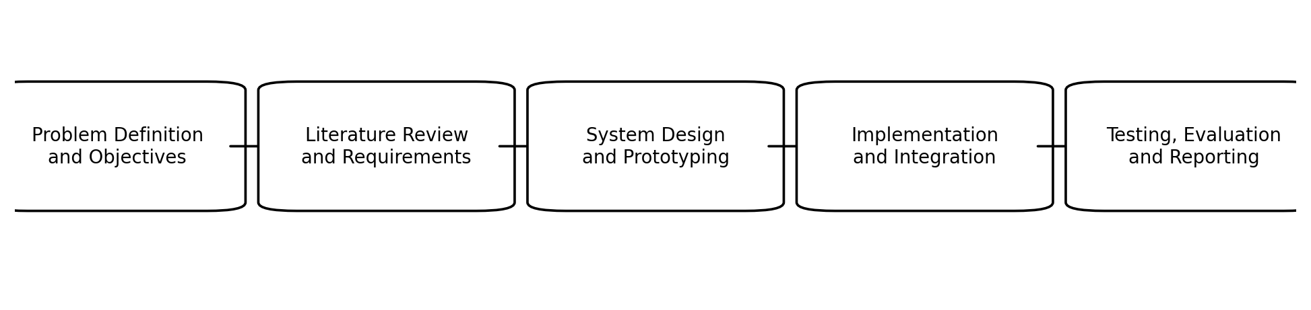
Figure 1: Proposed methodology process
Problem definition and objectives: Clarify the communication problem, identify stakeholders and define measurable objectives.
Literature review and requirements: Review related systems and gather functional and non-functional requirements from intended users.
System design and prototyping: Prepare the architecture, database design, interface mock-ups and notification workflows.
Implementation and integration: Develop the web application and integrate authentication, database, messaging, email and SMS services.
Testing, evaluation and reporting: Conduct functional, performance, reliability and usability testing; analyze findings and document conclusions.

3.2 Requirements and Data Collection
Requirements will be gathered through observation of existing communication practices, informal interviews or structured discussions with representative administrators, lecturers and students, and review of relevant institutional documents. The collected information will be grouped into functional requirements, such as authentication, targeted announcements, messaging, schedules and notification delivery, and non-functional requirements, such as security, usability, maintainability, accessibility and performance.

3.3 Development Approach
An Agile development approach will be used to organize the work into short iterations. Each iteration will deliver a usable part of the system for review. Early iterations will focus on authentication, user roles and the core data model. Later iterations will add announcements, messaging, academic information, notification services and administrative dashboards. Feedback from demonstrations and testing will guide corrections and improvements before the next iteration.

3.4 Conceptual and Architectural Framework of the Main System
The proposed system will use a layered modular architecture. Users will interact with a responsive presentation layer that provides role-specific dashboards. Requests will be handled by the application layer, which will enforce authentication, authorization, validation and business rules. The data and integration layer will manage database operations and external services such as email, SMS and media storage. A relational database will preserve institutional records and the relationships among users, departments, programmes, courses, announcements and transactions.
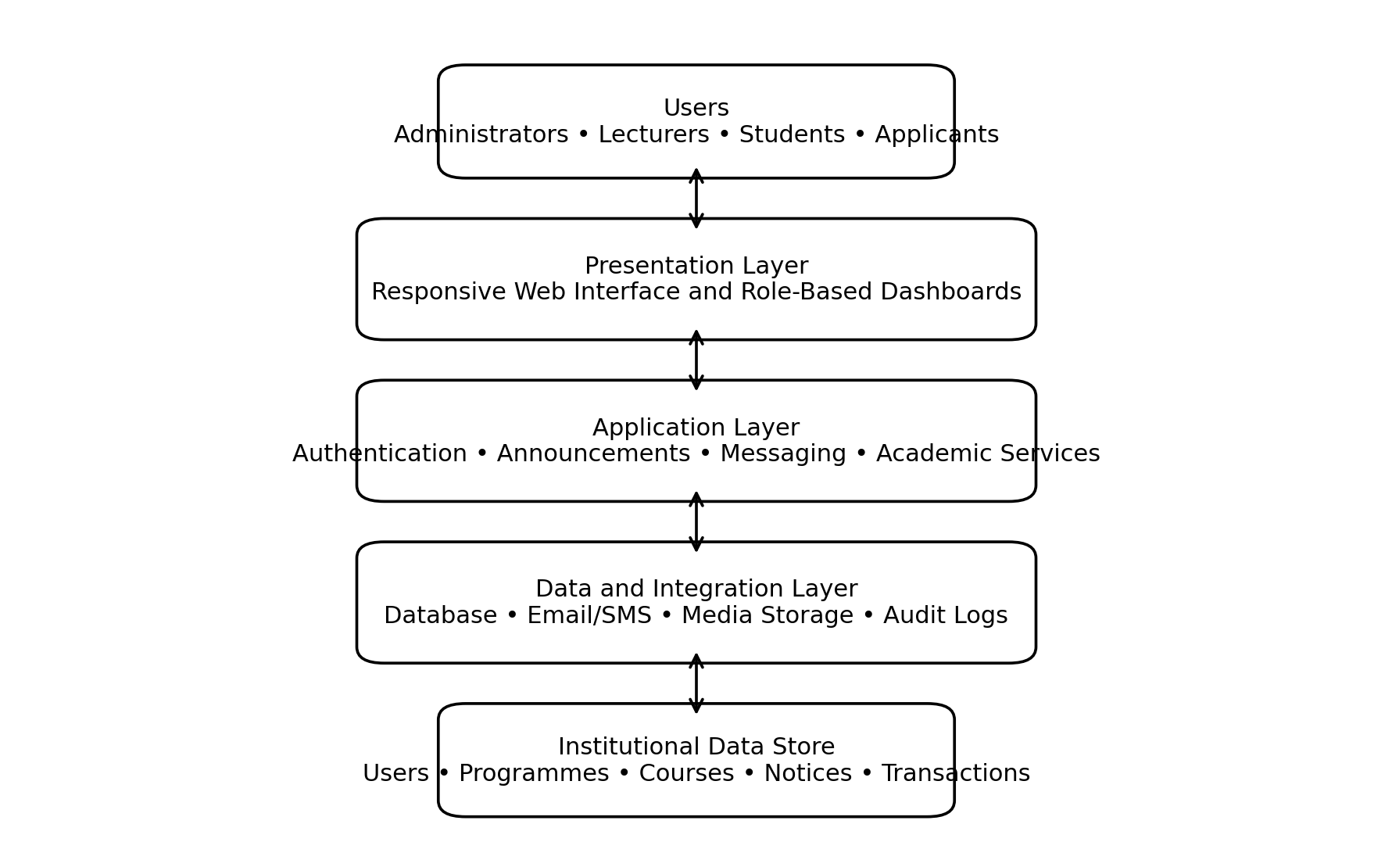
Figure 2: High-level architecture of the proposed system
The presentation layer will provide separate views for administrators, department administrators, lecturers, students and applicants. The application layer will contain modules for authentication, announcements, messaging, academic schedules, enrollment and notifications. The data and integration layer will support persistent storage, email and SMS delivery, media uploads and audit information. This separation will make the system easier to test, maintain and extend.

3.5 Proposed Technology Environment
Area | Proposed Technology
Frontend | Next.js and React with a responsive component library
Backend | Next.js server routes or a compatible Node.js service layer
Database | PostgreSQL managed through Prisma ORM
Authentication | Secure session-based authentication with role-based access control
Client data and state | React Query, Axios and Zustand where appropriate
Validation | Zod schemas and database constraints
Notifications | In-app notifications with email and SMS integration
Media storage | Cloud-based image and file storage

3.6 Testing and Evaluation Metrics
The prototype will be evaluated against criteria that directly correspond to the project objectives. Testing will include unit testing of individual components, integration testing of connected modules, system testing of complete workflows and user acceptance testing with representative users.
Metric | Definition | Measurement Method | Target
Functional accuracy | Percentage of required functions that operate correctly | Passed test cases ÷ total test cases × 100 | At least 90%
Response time | Time taken to load key pages or complete common requests | Browser and server timing tools | Most common actions within 3 seconds
Notification reliability | Proportion of notifications successfully created or delivered | Successful notifications ÷ attempted notifications × 100 | At least 95% for in-app delivery
Usability | Ease with which users complete representative tasks | Task completion rate and observed errors | At least 85% task completion
User satisfaction | Users' overall perception of usefulness and ease of use | Five-point questionnaire | Mean score of at least 4.0
Security and access control | Correct restriction of protected features by role | Role-based authorization test cases | No critical access-control failure

3.7 Ethical and Security Considerations
The project will minimize the collection of personal data and restrict access according to institutional roles. Passwords and sensitive information will not be stored in plain text. Test participants will be informed about the purpose of the evaluation, and any feedback collected will be used only for the project. The design will also include audit records for important administrative actions and controls for protecting confidential student information.

4.0 CONCLUSION
This proposal outlines the design and development of a smart information dissemination system for higher education. The project addresses the fragmentation of university communication by providing a centralized, role-based and traceable web platform for announcements, messaging, notifications and selected academic information. The proposed methodology combines requirements analysis, literature review, iterative design, implementation and systematic evaluation.
The expected contribution of the project is a practical prototype that improves the timeliness, relevance and accessibility of institutional communication while reducing repeated manual effort. Evaluation through functional, performance, reliability and usability measures will determine whether the system satisfies its objectives and provides a suitable foundation for future institutional deployment.

REFERENCES
Davis, F. D. (1989). Perceived usefulness, perceived ease of use, and user acceptance of information technology. MIS Quarterly, 13(3), 319-340.
Fielding, R. T., & Taylor, R. N. (2000). Architectural styles and the design of network-based software architectures. University of California, Irvine.
Nielsen, J. (1993). Usability engineering. Academic Press.
PostgreSQL Global Development Group. (2026). PostgreSQL documentation.
Prisma Data, Inc. (2026). Prisma ORM documentation.
Vercel, Inc. (2026). Next.js documentation.
World Wide Web Consortium. (2018). Web Content Accessibility Guidelines (WCAG) 2.1.

